The Longfellow Midtown Community
Coming soon to Dayton, Ohio
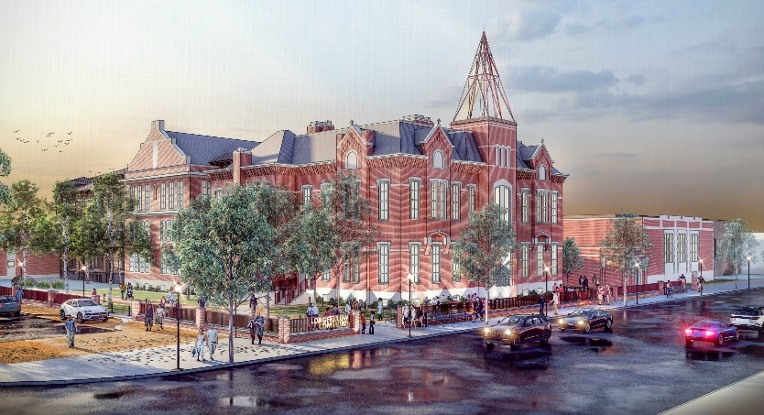
The former Longfellow School property at 245 Salem Avenue is poised for an innovative $35M adaptive reuse after receiving federally funded and competitive Historic Tax Credit approval.
The campus, purchased by The G.F. Bailey Company and Weyland Ventures in 2020 will be repurposed into a 150-unit age 55-plus residential community that will be intentionally programmed as welcoming for the LGBTQ+ community and allies. United Church Homes, Inc. (UCH), the senior living community partner in the project, has a long commitment to LGBTQ+ inclusive initiatives and a focus on providing safe and secure housing for older adults. Founded in 1916, Marion, Ohio-based United Church Homes owns or manages nearly 80 retirement communities in 14 states and two native American nations.
UCH owns four senior living communities in greater Dayton. Over 80 percent of its employees have received LGBTQ+ cultural competency training by SAGECare, a national organization. It has also partnered with Rainbow Elder Care of Greater Dayton to present the Horizons of Aging Summit, spotlighting unique challenges LGBTQ+ older adults face in accessing healthcare and aging services.
“This adaptive reuse of Longfellow has brought together the right people with the right purpose at the right time,” said Tim Forbess, CEO, The G.F. Bailey Company, one of the project’s developers.
“We were glad to find a community and partners who shared our passion for this unique project and had the experience and resources to make it a reality,” said Terry Spitznagel, Senior Executive Vice President and Chief Growth Officer. United Church Homes. “We believe this project will have wide-ranging appeal to older adults in the area and from the Midwest and beyond who desire to live in an intentionally inclusive, safe and welcoming community.”
Forbess, who built G.F. Bailey as a mission based company focused on driving investment into disinvested areas, praised the key partners in the building of Longfellow Midtown. “Without any one participant involved, we would not have made it to this point,” he said.
Weyland Ventures, a Louisville based developer, has worked extensively in the Dayton market. The company is responsible for the adaptive reuse of the Wheelhouse, the Dayton Motor Car Building and is in final stages of construction planning of the new “503”, a 158-unit apartment building in Oregon East.
Construction is anticipated to commence on the Longfellow Midtown Campus in late 2022, with occupancy beginning in late 2023.

